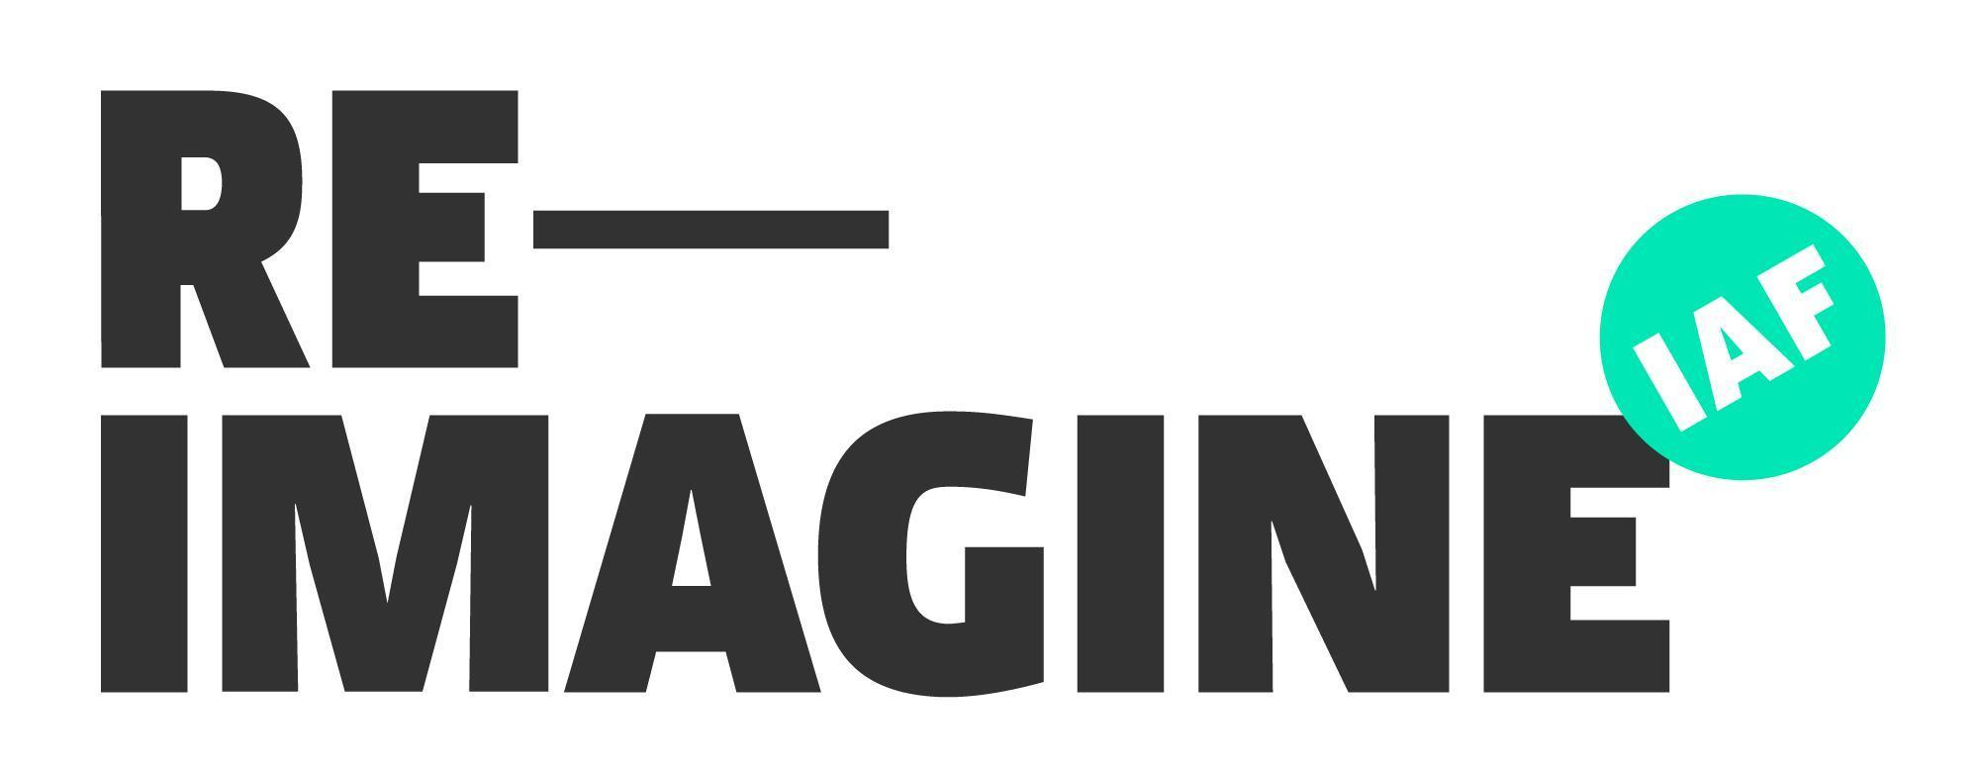

Press Release
Date
Heading

Sub heading: 1 line summary of contents of press release

Body: 1 – 1.5 pages describing the event/project. Include details on:
- What happened/will happen?
- Where did it happen?
- Who is involved?
- What is the key takeaway?
- Quotes from 1-2 key people

This project is part of the Irish Architecture Foundation’s Reimagine programme.

ENDS

Contact: Name, phone, email address

Notes to the editor:
X & Y person (include contact details) may be contacted for interview.

About Reimagine

Reimagine works with communities across Ireland to co-create and co-design solutions to problems or opportunities they’ve identified in their locality. Reimagine matches architects with local partners, enabling communities to play an active role in the development of their neighbourhoods, streetscapes, parks, villages and towns. Reimagine is funded by the Arts Council and Department of Rural and Community Development, with additional funding through the Department of Housing, Local Government and Heritage. To stay up to date on this project, visit www.reimagineplace.ie.

Established in 2005, the IAF is an independent organisation dedicated to the promotion of architecture as culture. The IAF seeks to champion the power of architecture to transform lives and improve the places where we live, learn, work and play. For further information on the IAF, visit www.architecturefoundation.ie.

Follow the IAF on Twitter, Facebook, Instagram and LinkedIn.

Include 3-4 photos

